HAD LAB FLUTTER XYLOPHONE PROGRAM

ADARSH ED
1NT20IS400

MAIN.dart file:

import 'package:flutter/material.dart';
import 'package:audioplayers/src/audio_cache.dart';
void PlayAudio(int i){
final player = AudioCache();
player.play("assets_note$i.wav");
}
void main() {
runApp(
MaterialApp(
home: Scaffold(
appBar: AppBar(title: Text("XYLOPHONE !"),centerTitle: true,),
body: Xylopage(),
),
)
);
}
class Xylopage extends StatefulWidget {
const Xylopage({Key? key}) : super(key: key);
@override
_XyloPageState createState() => _XyloPageState();
}
class _XyloPageState extends State<Xylopage> {
@override
Widget build(BuildContext context) {
return Column(
crossAxisAlignment: CrossAxisAlignment.stretch, // Setting the column to occupy full screen width horizontally
children: [
Expanded(child: TextButton(
style: TextButton.styleFrom(
backgroundColor: Colors.amber
),
onPressed: (){
PlayAudio(1);
}, child: const Text('First'),
),),
Expanded(child: TextButton(
style: TextButton.styleFrom(
backgroundColor: Colors.cyanAccent
),
onPressed: (){
PlayAudio(2);
}, child: const Text('Second'),),),
Expanded(child: TextButton(
style: TextButton.styleFrom(
backgroundColor: Colors.purple
),
onPressed: (){
PlayAudio(3);
}, child: const Text('Third'),),),
Expanded(child: TextButton(
style: TextButton.styleFrom(
backgroundColor: Colors.green
),
onPressed: (){
PlayAudio(4);
}, child: const Text('Fourth'),),),
Expanded(child: TextButton(
style: TextButton.styleFrom(
backgroundColor: Colors.red
),
onPressed: (){
PlayAudio(5);
}, child: const Text('Fifth'),),),
Expanded(child: TextButton(
style: TextButton.styleFrom(
backgroundColor: Colors.brown
),
onPressed: (){
PlayAudio(6);
}, child: const Text('Sixth'),),),
Expanded(child: TextButton(
style: TextButton.styleFrom(
backgroundColor: Colors.black
),
onPressed: (){
PlayAudio(7);
}, child: const Text('Seventh'),),)
]);
// Build the Widget Tree here
}
}

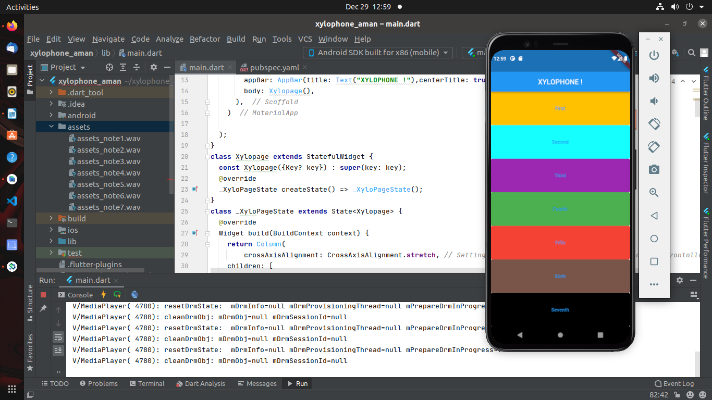

PUBSPEC.yaml

name: xylophone_aman
description: A new Flutter project.
# The following line prevents the package from being accidentally published to
# pub.dev using `flutter pub publish`. This is preferred for private packages.
publish_to: 'none' # Remove this line if you wish to publish to pub.dev
# The following defines the version and build number for your application.
# A version number is three numbers separated by dots, like 1.2.43
# followed by an optional build number separated by a +.
# Both the version and the builder number may be overridden in flutter
# build by specifying --build-name and --build-number, respectively.
# In Android, build-name is used as versionName while build-number used as versionCode.
# Read more about Android versioning at https://developer.android.com/studio/publish/versioning
# In iOS, build-name is used as CFBundleShortVersionString while build-number used as CFBundleVersion.
# Read more about iOS versioning at
# https://developer.apple.com/library/archive/documentation/General/Reference/InfoPlistKeyReference/Articles/CoreFoundationKeys.html
version: 1.0.0+1
environment:
sdk: ">=2.12.0 <3.0.0"
# Dependencies specify other packages that your package needs in order to work.
# To automatically upgrade your package dependencies to the latest versions
# consider running `flutter pub upgrade --major-versions`. Alternatively,
# dependencies can be manually updated by changing the version numbers below to
# the latest version available on pub.dev. To see which dependencies have newer
# versions available, run `flutter pub outdated`.
dependencies:
audioplayers: ^0.19.1
flutter:
sdk: flutter
# The following adds the Cupertino Icons font to your application.
# Use with the CupertinoIcons class for iOS style icons.
cupertino_icons: ^1.0.2
dev_dependencies:
flutter_test:
sdk: flutter
# The "flutter_lints" package below contains a set of recommended lints to
# encourage good coding practices. The lint set provided by the package is
# activated in the `analysis_options.yaml` file located at the root of your
# package. See that file for information about deactivating specific lint
# rules and activating additional ones.
flutter_lints: ^1.0.0
# For information on the generic Dart part of this file, see the
# following page: https://dart.dev/tools/pub/pubspec
# The following section is specific to Flutter.
flutter:
# The following line ensures that the Material Icons font is
# included with your application, so that you can use the icons in
# the material Icons class.
uses-material-design: true
assets:
- assets/
# To add assets to your application, add an assets section, like this:
# assets:
# - images/a_dot_burr.jpeg
# - images/a_dot_ham.jpeg
# An image asset can refer to one or more resolution-specific "variants", see
# https://flutter.dev/assets-and-images/#resolution-aware.
# For details regarding adding assets from package dependencies, see
# https://flutter.dev/assets-and-images/#from-packages
# To add custom fonts to your application, add a fonts section here,
# in this "flutter" section. Each entry in this list should have a
# "family" key with the font family name, and a "fonts" key with a
# list giving the asset and other descriptors for the font. For
# example:
# fonts:
# - family: Schyler
# fonts:
# - asset: fonts/Schyler-Regular.ttf
# - asset: fonts/Schyler-Italic.ttf
# style: italic
# - family: Trajan Pro
# fonts:
# - asset: fonts/TrajanPro.ttf
# - asset: fonts/TrajanPro_Bold.ttf
# weight: 700
#
# For details regarding fonts from package dependencies,
# see https://flutter.dev/custom-fonts/#from-packages
